Important slides

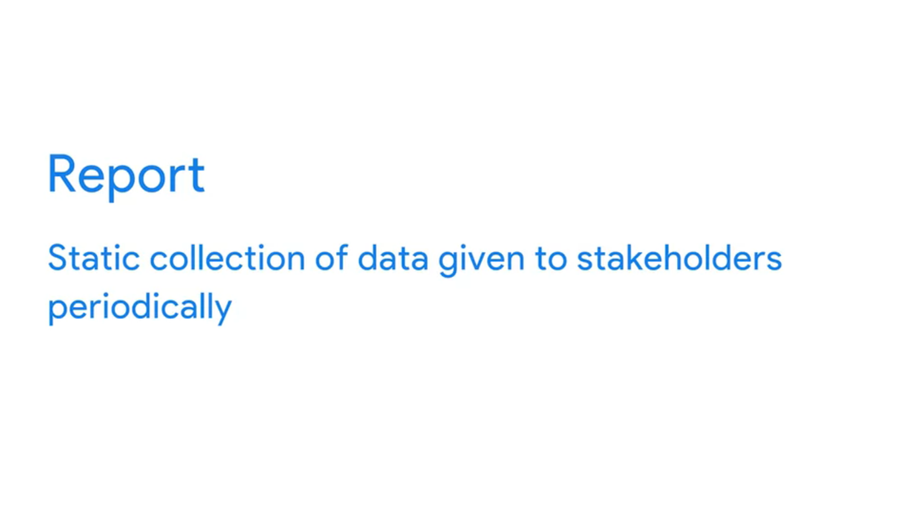

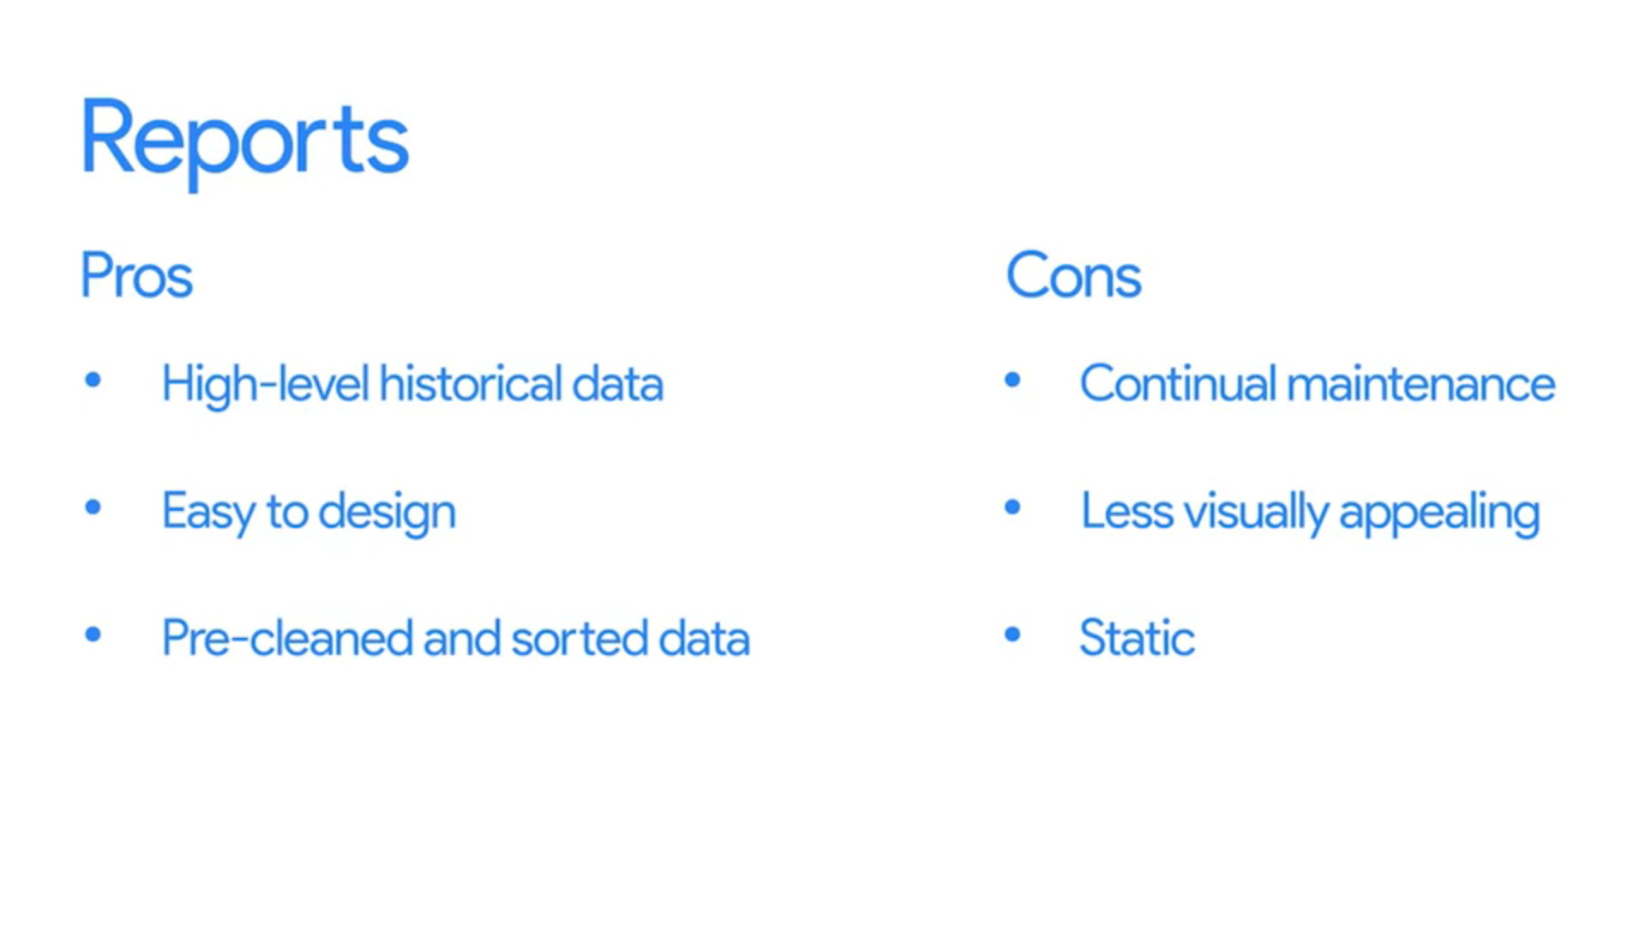

Example of report

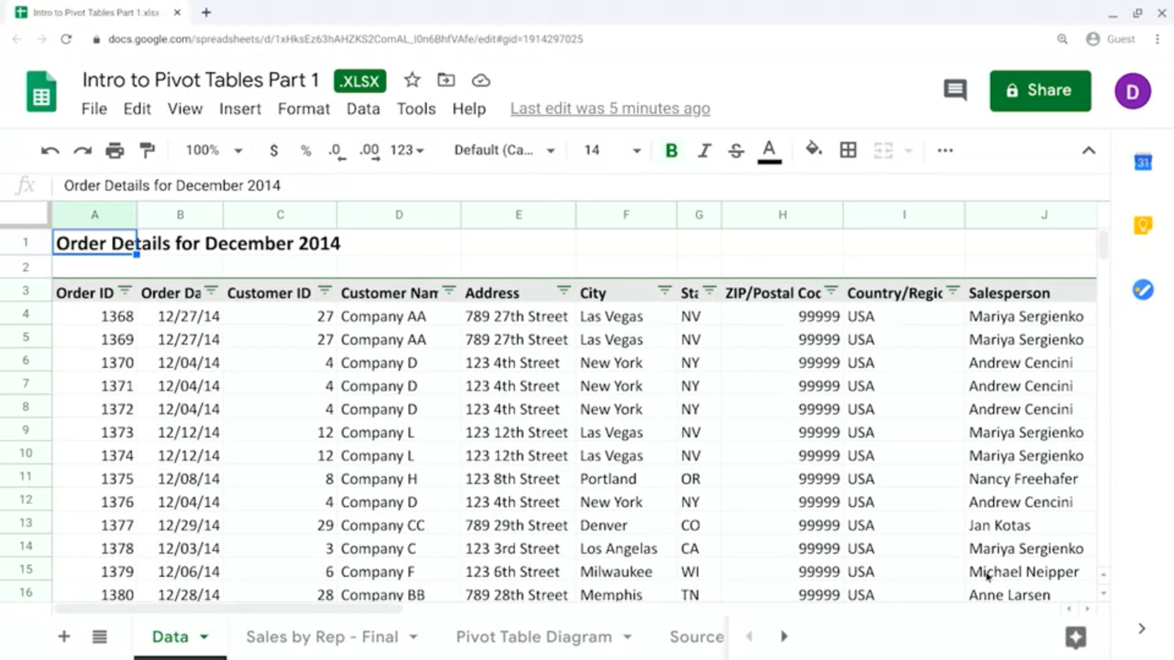

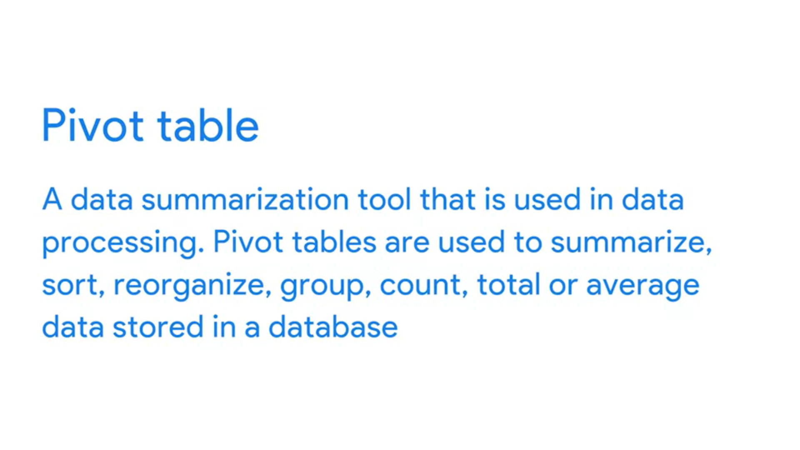

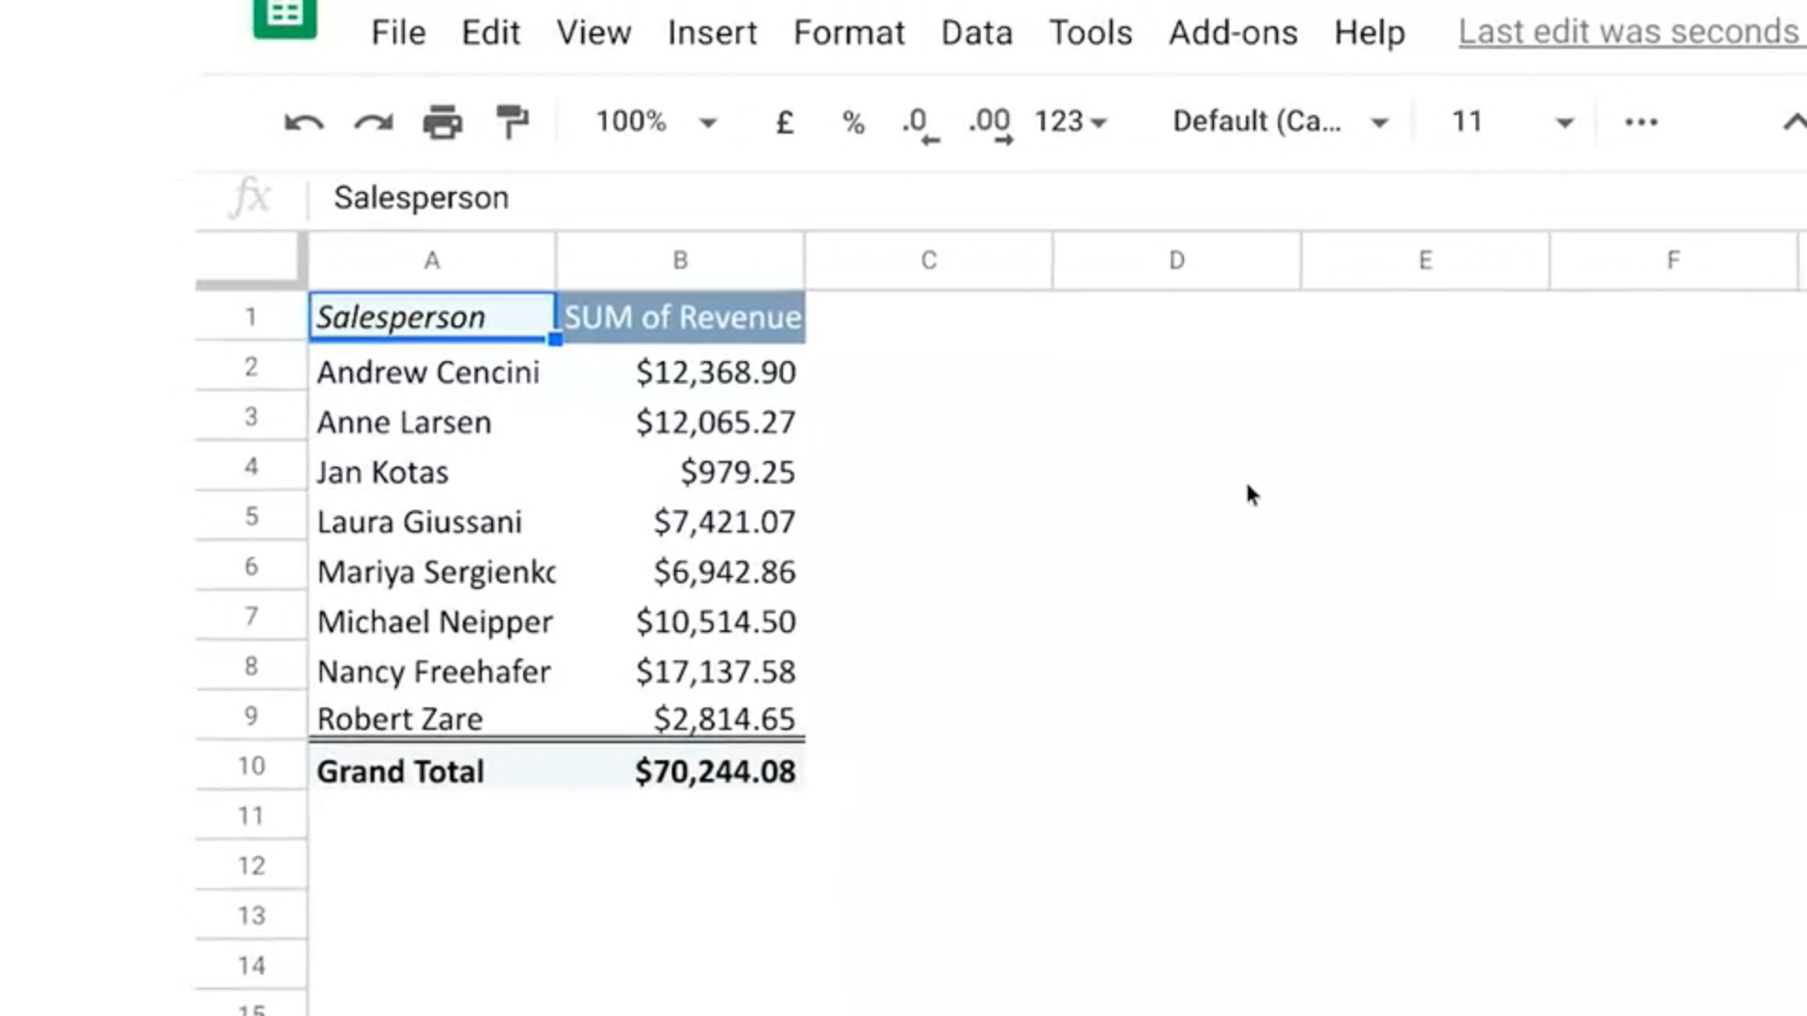

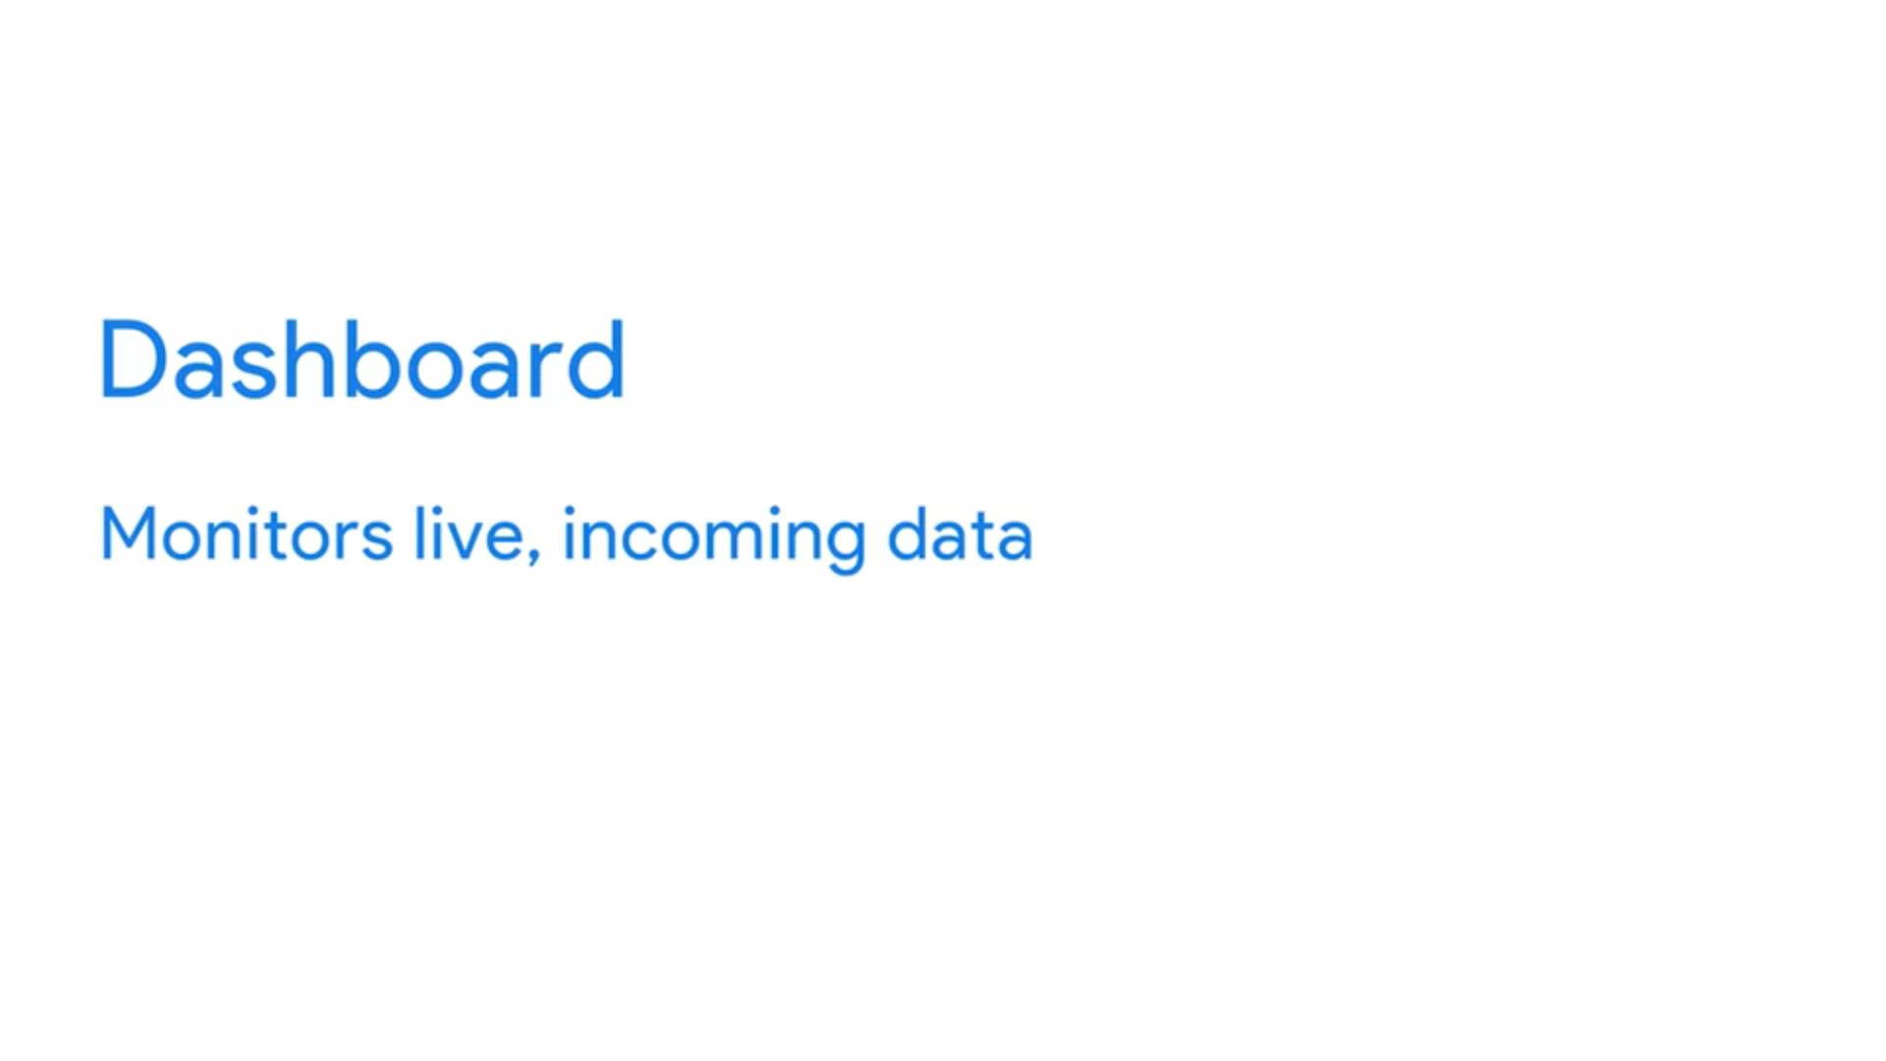

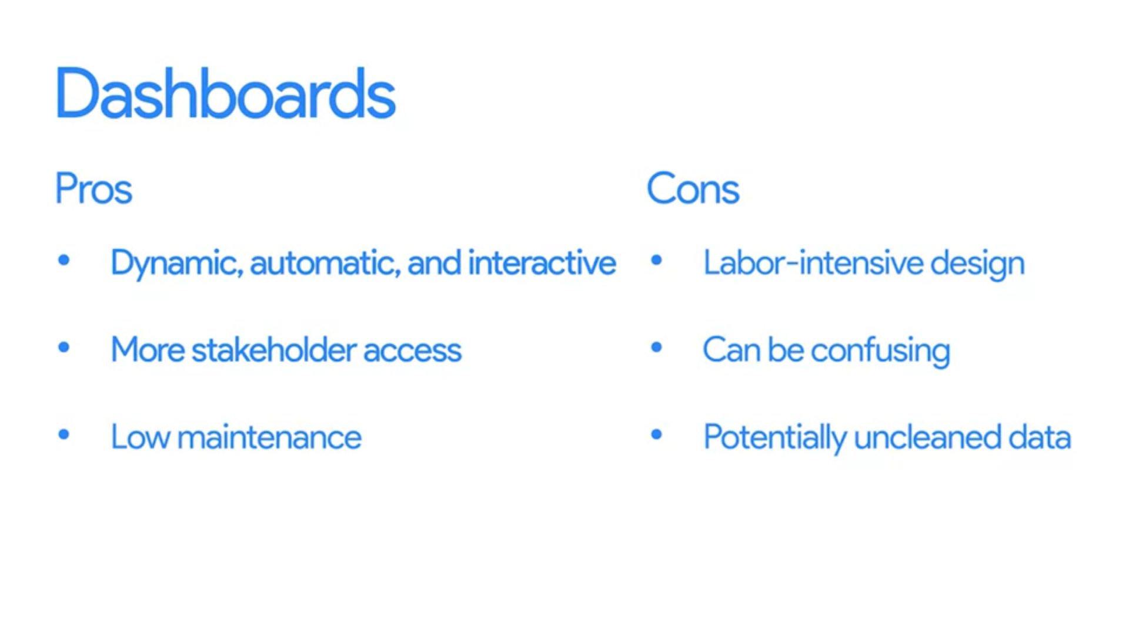

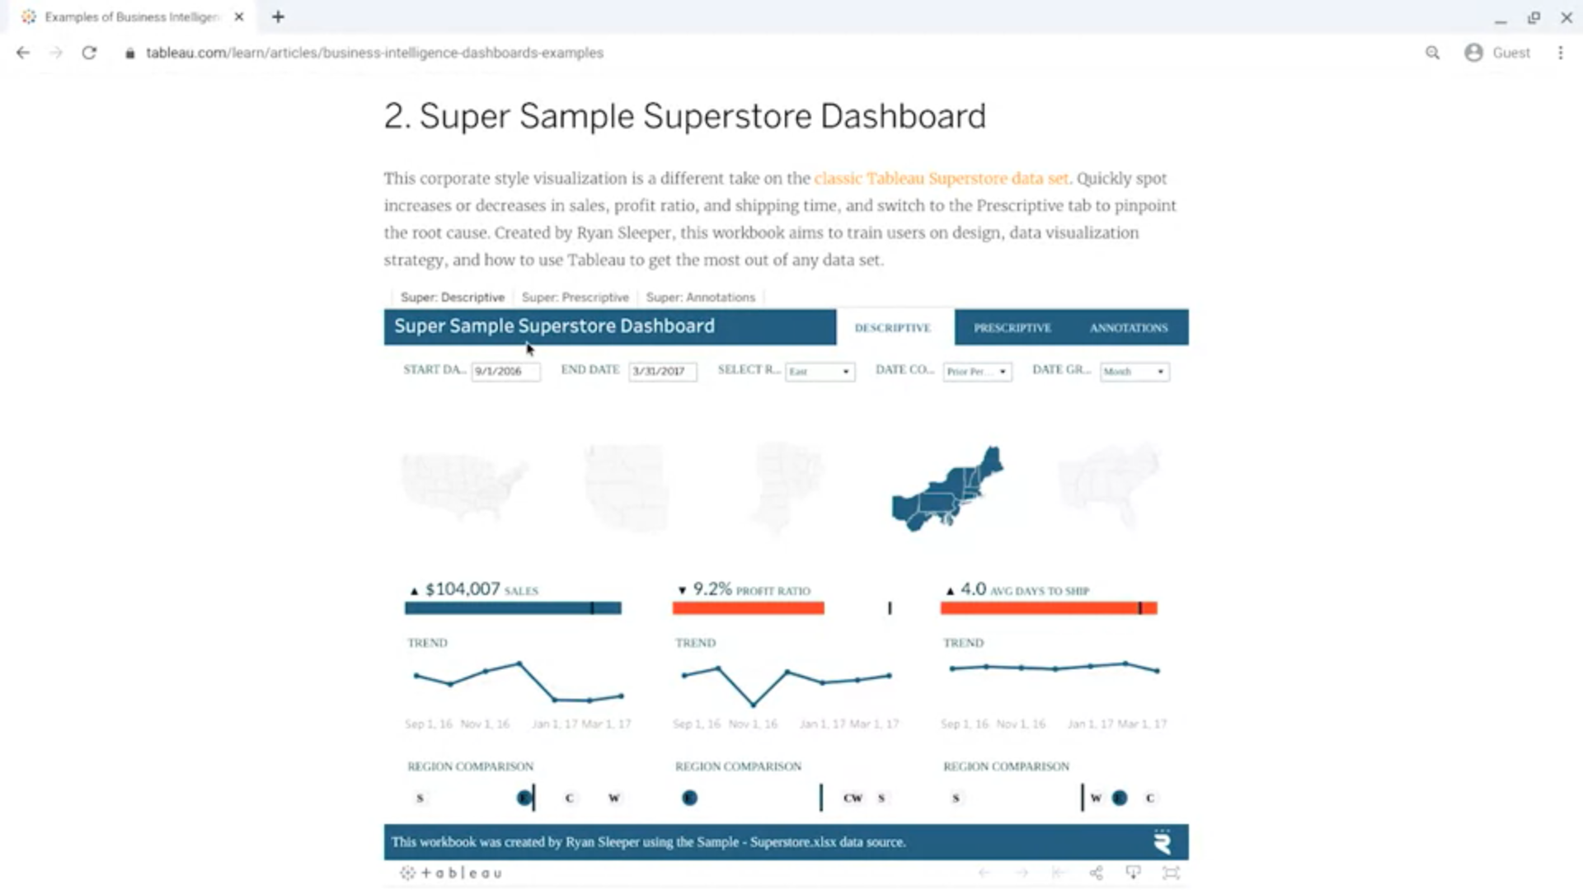

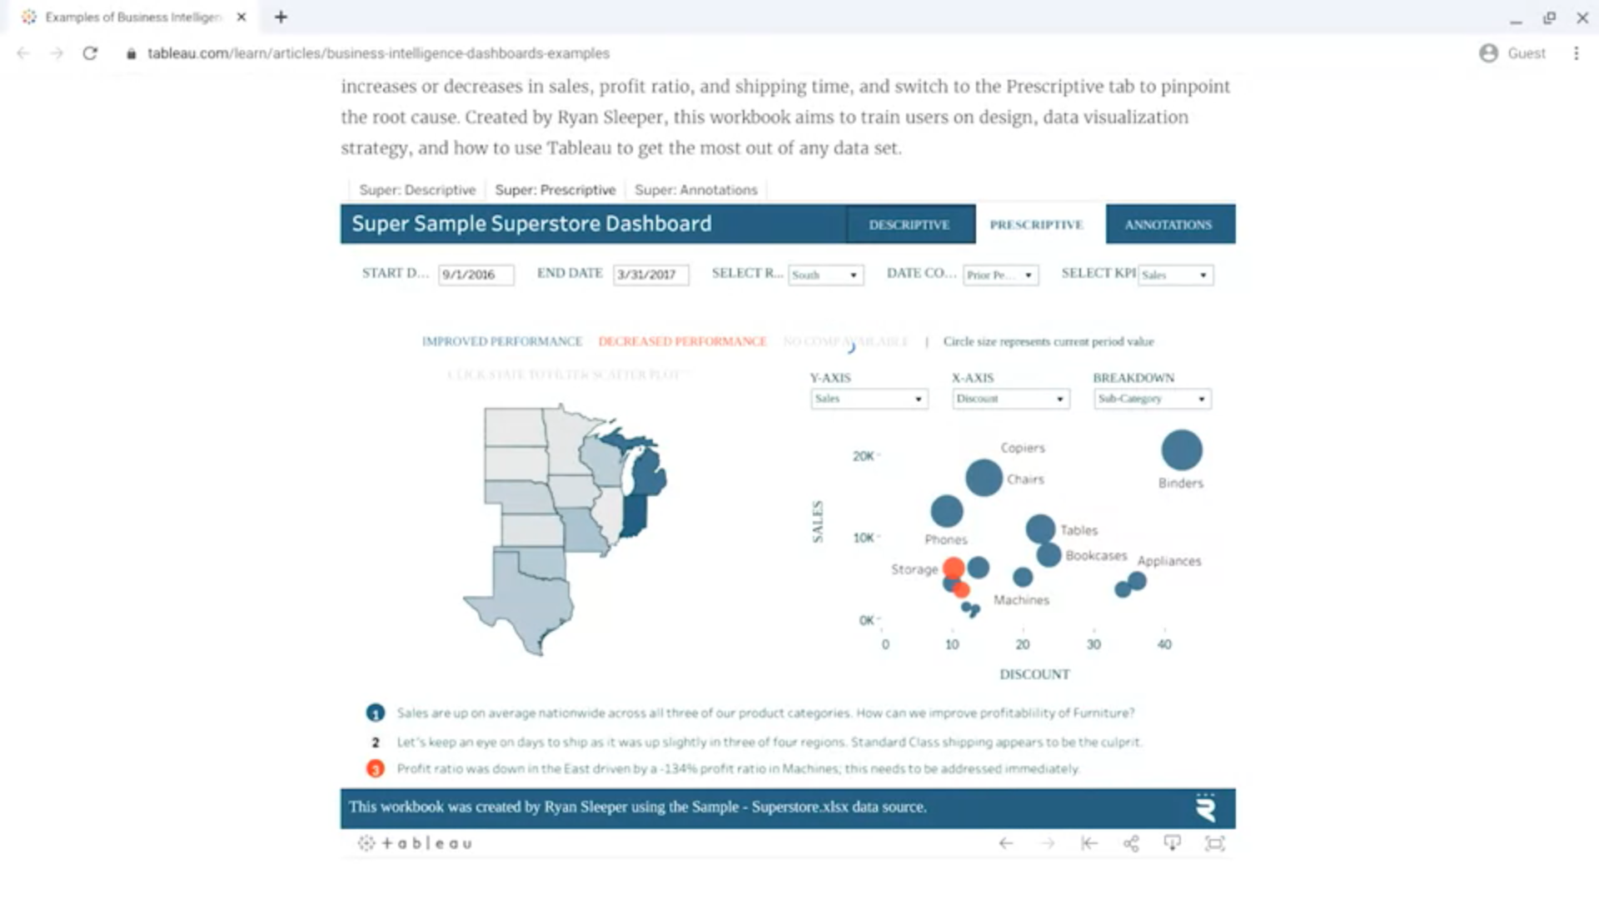

Metric

**Metrics** are the numbers you track, and **analytics** implies analyses and decision-making. ... **Metrics**: What you measure to gauge performance or progress within a company or organization. Your most important **metrics** are your key performance indicators or KPIs.

What are examples of metrics?

**Sales Metrics**

* Sales Growth.
* Average Profit Margin.
* Average Purchase Value.
* Product Performance.

